

Prospectus and Enrolment Pack
2019 – 2021

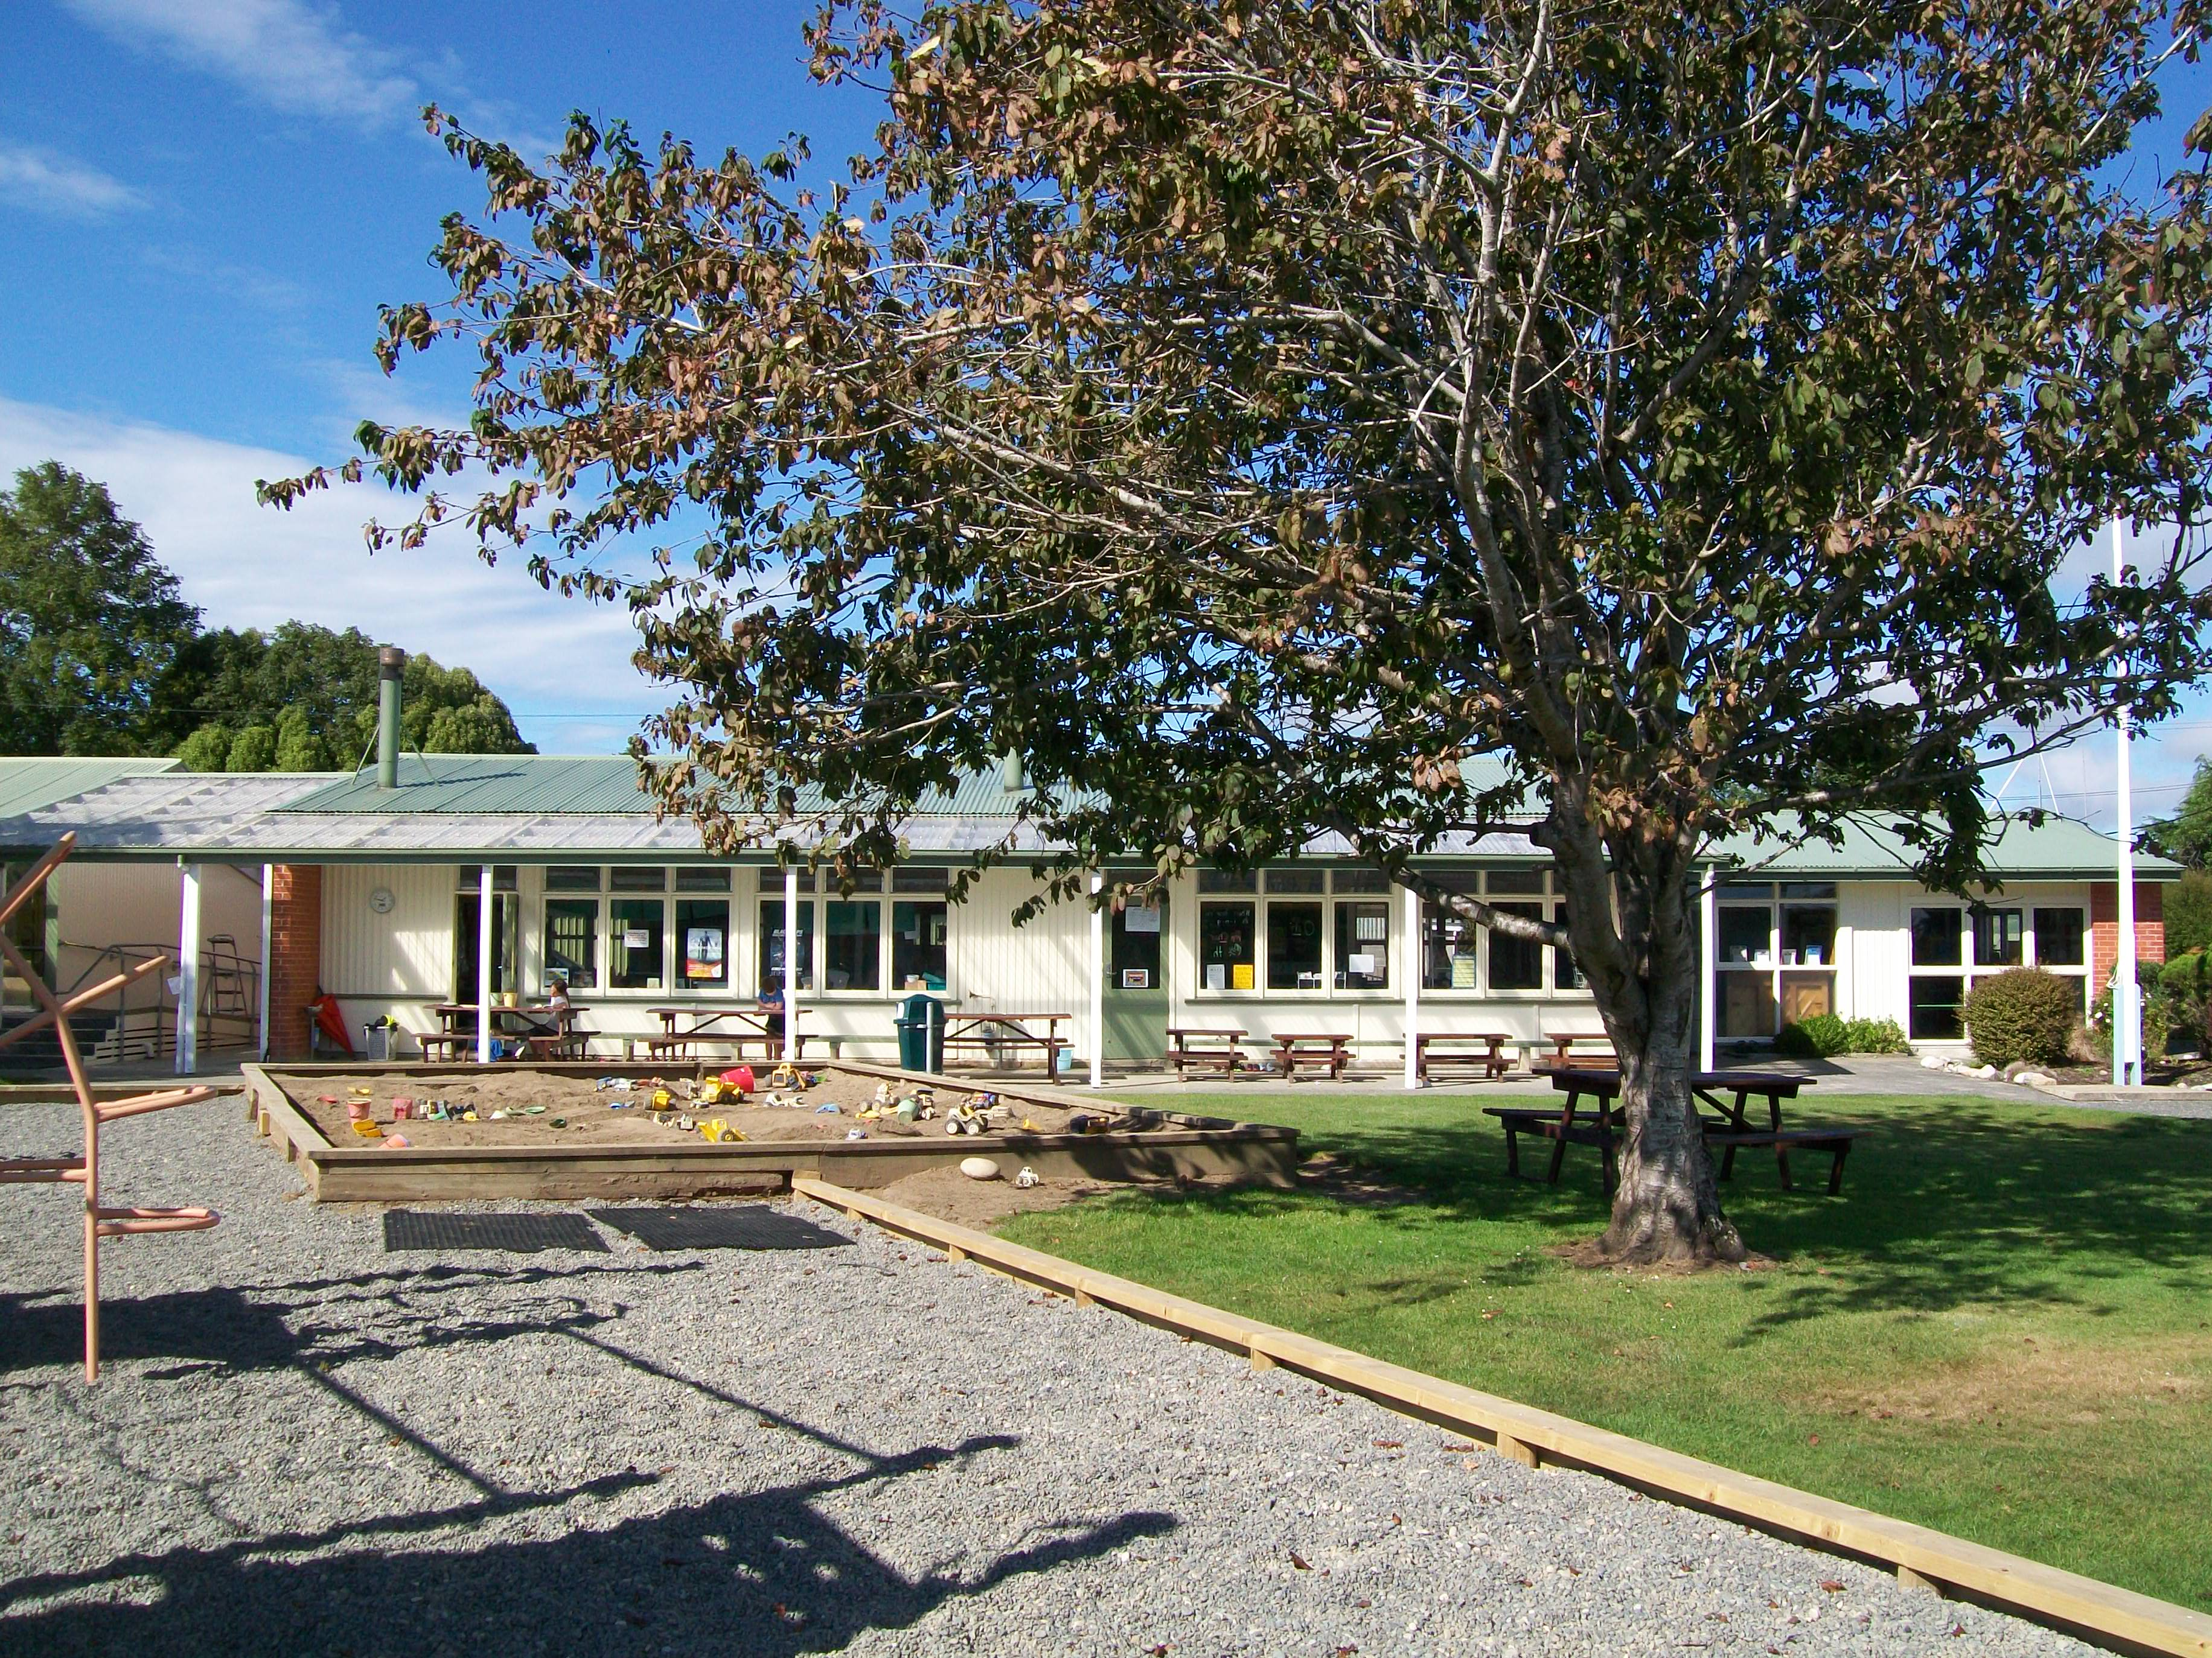
Welcome to Hauroko Valley Primary

Kia ora and welcome to Hauroko Valley Primary School. We are a U2 contributing school located 10 minutes north of Tuatapere. Hauroko Valley Primary is a community focussed school, with most of our students coming from farming families in the Clifden, Orawia, Eastern Bush and Blackmount areas.

We have strong links with our school families and the wider community. We are proud of our location and history, and use our rural setting, Lake Hauroko and the Clifden Suspension Bridge as symbols for our learning and ways of thinking.
Our school has around 85 students in four classrooms, and is well resourced with great facilities such as a modern library, a heated swimming pool and access to ultrafast broadband. We are well supported by a great teaching staff and a proactive Board of Trustees.
We provide our children with a caring and supportive environment to encourage individual achievement.
We take great pride in our school and are proud of our pupils. We welcome the opportunity to share this with you by inviting you to visit the school to see our curriculum in action. We are happy to answer any questions you may have. Enrolments are invited from new entrants to Year 8.

The school provides a caring, supportive, secure and stimulating environment for children.

This prospectus contains relevant information about the school, which we hope you will find useful in familiarising yourself with the school. If you have any queries/questions, please either phone (03 226 6753) or email principal@haurokovalley.school.nz

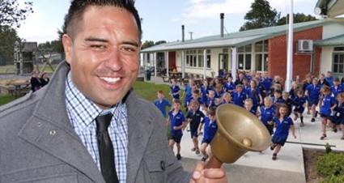
Principal – Glenn Puna
Our Mission Statement
Working together for tomorrow

Our Vision
Hauroko Valley Primary School will provide students with opportunities to enable them to realize individual potential and become motivated learners who strive for excellence and can adapt to the constant changes in the global community.

To achieve this vision the Hauroko Valley Primary School community will ensure that students are being challenged throughout our school curriculum and that opportunities within the community are made accessible to our children.

Our Motto
Always our Best



School Curriculum

Curriculum Overview
The New Zealand Curriculum guides all decisions around curriculum. The Hauroko Valley Primary School Curriculum is structured into three key areas.

- English
- Mathematics and Statistics
- The Hauroko Inquiry / Integrated Curriculum


At Hauroko Valley Primary School English, Mathematics and Statistics are the prioritised learning areas. They are specifically timetabled and taught during optimal learning times with explicit teaching of identified skills and strategies. Teachers will however make links to our Hauroko Inquiry/Integrated Curriculum to provide an authentic context for learning. The Key Competencies will be integrated into the school curriculum.
The Hauroko Inquiry/Integrated Curriculum incorporates the teaching and learning of Science, Social Science, Technology, The Arts, Health and Physical Education and Learning Languages. It is based around key concepts and enduring understandings that we have identified as being both essential and relevant for our students. These concepts provide natural links across learning areas and ensure coverage of all strands.
At Hauroko Valley Primary School we developed a 3 year cycle to ensure that there is appropriate coverage of the identified learning concepts and corresponding enduring understandings, ensuring all strands are covered over this period of time. Staff will review every 3 years and choose concepts relevant and essential to our children and environment.
Possible concepts include: Energy, Diversity, Systems, Change, Interactions, Sustainability, and Challenge
Inquiry/Integrated Curriculum Implementation Framework
Year - Concept
2019
Energy

2020
Change

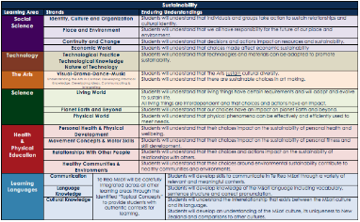
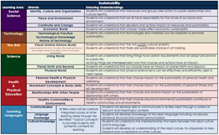
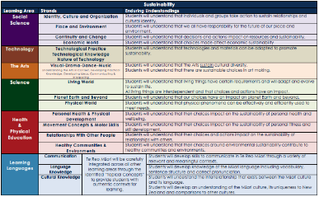



At Hauroko Valley Primary School the staff and children learn about and adopt the Hauroko Values. These values are used to influence and reward positive behaviour and guide how we interact with each other, our environment and our commitment to learning.

SCHOOL ACTIVITIES

The school offers a wide range of activities that everyone takes part in. The well sheltered playing fields; tennis/netball court, community swimming pool and adventure playground enhance our facilities.

Music/Drama— Performers are regular visitors to the school. School productions are bi-annually and School singing is held weekly.
Education outside the classroom includes ski trips; school camps and curriculum based field trips.
Library, Book Fair and Pet Show.
Leadership opportunities (Spirit of the Nation, School leaders, Class leaders, Bus Monitors, Assembly leaders, PAL’s).
Variety of inter school sporting opportunities - Athletics, cross country, swimming, netball, golf
Life Education, Police Education officer, Environment Southland, Speech Comp, South Spell, PAT Testing, Current events/trivia inter school comps, BP Technology Challenge, ANZAC Day Dawn Service.
ICT: computer ratio 1: 3 children.

Sports’ coaching is available throughout the year with Sport Southland coaches or from the assistance of our strong parent community.

BOARD OF TRUSTEES

Function of Board of Trustees

The Board is committed to providing the very best education for the pupils of HVP and to foster a supportive and stimulating environment that promotes development of lifelong learners.

The Board is responsible for the maintenance and development of the school’s facilities and is the employer of the school’s staff.

The day to day running of the school, internal organisation of classes and teaching programmes, are the responsibility of the Principal and Staff.

The Board of Trustees meet monthly and meetings are advertised in the school newsletter. Parents/caregivers are welcome to attend meetings. The minutes of each meeting and Policies prepared by the Board and Staff are kept in the office and are available.
Parents/caregivers are kept informed through the school weekly newsletter, the school website and Facebook.

Please take the time to look over our school charter. Available on the school website or through the school office.

HOME & SCHOOL COMMITTEE

The aim of the Home & School is to fill the social need of the school by way of organising social activities, making contact with new parents, sick or bereaved families and in general be the link between parents and the school. Home & School also continues to help with fundraising and catering for various school and community functions.
Our H & S works closely with the BOT and staff to meet the needs of both school and parents.

Meetings are held regularly and dates advertised through the school newsletter.

ABSENCES
If your child is absent please notify the school in writing or by phone either prior to the day of absence or before school on the day of absence. A staff member will check all absences between 9-9.30am and parents of pupils with unexplained absences will be phoned. If your child has to leave school during the day please ensure the class teacher is notified before the child leaves.

ACCIDENTS AND FIRST AID
Minor injuries in the playground are treated in the medical area and the child returned to class when it is certain there are no problems. For more serious accidents, parents/caregivers are contacted and asked to collect the child for medical treatment. If the parents/caregivers are unavailable, the child will be taken to the local Medical Centre and the advice of the doctor will be followed until the parent/caregiver is contacted.
A list is kept of children with allergies and medical conditions, so please notify the school if your child needs to be included on this list. In situations where a child needs medication, parents/caregivers are required to complete the documentation in the school’s Medical Administration Register or send written instructions regarding the administration of the medicine to the school office along with the medication. Staff will administer medication with parent’s permission and adequate training. Medications are stored appropriately.

ANSWER PHONE
The school office is not attended all day. Please leave messages on the answer phone. These are cleared at morning tea, lunchtime and after school (before buses leave). If you urgently need to contact the school and the answer phone is not working

ATHLETIC SPORTS
The school participates with Waiau Area School in Term 1. The venue is at Waiau Area School. The first two children in most events (aged 8 and over) are eligible to represent our area in the Western competition. Parents are responsible for transporting their children to and from this event, and also for supervising their children while there.

SCHOLASTIC NEW ZEALAND BOOKS
Order forms for Scholastic Books are sent home regularly. If your child would like to order a book, please return the form and the money to school by the due date or you can order online. Cheques should be made out to ‘Scholastic New Zealand’.

ASSEMBLY
A weekly assembly for the whole school is held most Friday afternoons at 2.30pm. (If not running will be mentioned in school newsletter and Facebook). Parents/caregivers are most welcome to attend this.

BEHAVIOUR MANAGEMENT
To ensure your child receives the quality education that they deserve, without disruption, a classroom discipline plan will be in effect at all times regardless of who is teaching the class. This is based on the expectation that no student will stop the teacher from teaching, or other students from learning. Behaviour is based on positive reinforcement for acceptable behaviour and are in line with the Hauroko Values.

BUSES
Our school is served by three bus runs. Eastern Bush, Lilburn and Orawia. The main bus contractor is Brazier Motors. If your child is new to the school and you wish to arrange bus transport – please contact Dan Sewpersad at Brazier Motors in Tuatapere (03) 226 6715.
Once transport has been arranged – if you make any changes (whether temporary or permanent) please contact the bus company. If your child needs to travel on a different bus please check with the bus company or the bus driver to see if there is a spare seat. Please do not assume that there will be, as some buses are full. The school also needs to be informed (by parents) of any changes.

Also, if your child is getting off the bus somewhere other than home, please contact the bus driver, or give your child a note. A verbal message is not acceptable, as children cannot be relied on for relaying messages accurately. The Principal is Bus Controller for Hauroko Valley Primary School.

CHILDREN’S HOME TOYS
Pupils are not permitted to bring toys to school unless requested by a teacher (in which case you will receive a written note.)

COMPLAINTS PROCEDURE
A complaints procedure is included in the enrolment pack and attached to the school newsletter during the year.

CROSS COUNTRY
We combine with Thornbury and Isla Bank. Each school takes a turn at hosting the Cross Country competition. Successful children go through to the Western competition.

DENTAL CLINIC
Dental services are available at Tuatapere on a regular basis. Parents are notified by the clinic of regular checkups. Parents are responsible for transporting their children.

ACTIVITY FEES
From time to time, classes may be involved in activities, which enhance curriculum delivery (trips, visiting artists, sports activities) and involve a small cost. A fee of $15.00 per term is included when school accounts are sent home. Again, please make contact with the Principal should alternative arrangements be required. You will receive a letter if your account is overdue.

DRINKS
Plastic pump style drink bottles are preferred, filled with water. Filtered water is available for refilling bottles. Children have free access to their drink bottles or the fountains (also filtered) during school time.

DUTY
Staff will be responsible for children once they arrive at school. Non-bus children being dropped off are welcome after the first bus arrives at approximately 8.25am. One staff member is rostered to be on duty during morning tea, lunchtime and until the departure of the last school bus (approximately 3.20pm).

EMERGENCY EVACUATION/SCHOOL CLOSURE PROCEDURE
Should the school close prior to opening in the morning (due to weather etc.) you will be phoned by a Hauroko Valley Primary School area contact person. It will also be posted on the schools Facebook page. Should the school close during school hours you will be contacted by the school staff. Children are not released for buses until a parent/caregiver has been contacted. Please ensure your emergency contact phone numbers are accurate.

FITNESS
As part of the physical education programme, each class takes part daily in 10-15 minutes of activity, which includes skipping, jump jam, dance, games, running, etc. This is a fun, non-competitive time. If your child has a health problem, which may be aggravated by such activity, please notify the school.

GROUP SPECIALIST EDUCATION
With parent consent, children with learning and/or behaviour problems may be referred for specialist help.
A Speech Therapist visits the school regularly. Teachers or parents refer children and then if accepted a programme is provided.

HEALTH NURSE
The Public Health Nurse visits the school on a regular basis and is available to discuss any small problems. Please phone the office to check when she will be available.

HEARING/VISION TESTING
The Hearing/Vision Technicians visit once a year. All five year olds also have their hearing and vision tested. Teachers, parents or caregivers may refer older children.

HEAD LICE/SCABIES
Head lice and scabies seem to be an on-going problem for most schools. If you child is infected please ensure correct treatment is given before the child returns to school. It does help if the school is notified so other parents/caregivers can be alerted. The school has Robi-combs, which may be borrowed.

HEALTH PROBLEMS
If your child has any health problems that could interfere with normal school activities please notify the office and class teacher.

HOMEWORK
Small amounts of homework each night foster development of good work habits for all children.
All children will bring home books to read.
All pupils will have written homework each week. This could include Maths, spelling activities, reading activities or work related to a topic being studied in the classroom. It is important that any homework activity is a positive experience for children. If the work is too difficult or takes longer than 30 minutes, please encourage the child to put it away and contact the class teacher.

LEAVING SCHOOL GROUNDS
Children may not leave the school grounds during the school day without a parent/caregiver or teacher. A written or verbal message from a parent/caregiver is necessary if a child is leaving school at a different time.

LIBRARY
The school has a library available for children to use. Children are limited to the number of books they can borrow at one time. We ask that parents keep a regular lookout for books at home and that all books be returned in the last week of the school year. The Southland District Council Book Bus also uses the school as a base for its visits. The bus is here on the first Monday of every month at 1-2pm. You will have to ask for your own library card and be responsible for any book you borrow.

LOST PROPERTY
Named uniform items will be given back to their owners. Unnamed items will be added to our school second hand clothing supplies if they have not been claimed after a month.

LUNCHES
Children may bring along food to be heated for lunch in the pie warmer. Food must be wrapped in foil, named and left in classrooms to be collected. Children are not permitted to bring lollies, chocolate or fizzy drinks to school.

The following lunch items are supplied by the Waiau Hotel, and are available on Fridays only. Please send correct money in an envelope with your child’s name and order on the outside.

Hot Dog and Chips…………………. $4.00 Chips...................................... $2.50
Chicken Nuggets & Chips................ $4.50 Crumbed Blue Cod & Chips… $5.00
Pie …………………………………… $3.50 Chicken Schnitzel & Chips …… $5.50
Savoury Muffin................................ $4.00 Filled Rolls..................................... $4.50
Dagwood Sandwich.......................... $4.00 Lolly Cake ……………………… $2.50



NEW ENTRANT INFORMATION

Visits
Please make contact with your child’s classroom teacher to arrange a suitable time to visit.
For New Entrants visiting prior to starting school for the first time, it is highly recommended that the child have up to five visits as close to the actual start date as possible (e.g. the five mornings before the child starts school).
This way the child becomes familiar with the structure of the morning programme, and gets to know the teachers and other students. Parents are welcome to stay for the first visit, but children usually join in with class activities more readily once Mum or Dad has left.
New Entrants who are visiting are encouraged to stay for lunch, which ends at 1.30pm.

Length of Day
It can take a term for a new entrant pupil to adjust to a 9am-3pm school day. If you child shows signs of tiredness a rest day may be required.

Birth Certificates / Immunisation Details
It is a requirement that a birth certificate be presented upon enrolment of every new entrant in every school. Birth certificate information can be obtained from Births, Deaths and Marriages, toll free 0800 225252.
The school must also keep a record of each child’s immunisation details. If the pupil being enrolled was not born in New Zealand, the school must make a copy of the child’s passport for birth date and student status information.

PHOTOCOPIER
The school photocopier is available for use by the community during school hours. Please contact the school to arrange a suitable time. Current photocopier costs are: Single sided A4 Black & White 10c/copy, A4 Colour 40c/copy.

REPORTING TO PARENTS
Newsletters
School newsletters are sent home every Friday. They are issued to the eldest or only child in each family.

Interviews
Goal setting interviews are held in Term 1 and 3. Parent/Teacher interviews are held following Mid Year Reports. At other times, please feel free to contact the appropriate staff member for information about your child’s progress or school activities. Please phone the office and arrange an appointment to ensure the teacher is available.

Parent Information Meetings
Meetings may be held from time to time, to inform parents about class programmes, or new curriculum developments.

ROAD SAFETY
Parents dropping off children at school use the area left of the main entrance. Pupils arriving by bus use the area in front of the entrance.

STATIONERY
Stationery items may be purchased at school throughout the year. Accounts are sent home at the end of each term. Prompt payment is appreciated. Parents/Caregivers are welcome to contact the school to arrange for alternative payment procedures, should this be unsuitable for them.

SWIMMING
School Swimming is in March and taught over 2 weeks. Because of the close proximity of water, we believe it is important that all children learn to swim as soon as possible. Therefore, we place a strong emphasis on swimming instruction. If for any reason your child is unable to swim, please contact the classroom teacher, or the office.
The Hauroko Valley Primary School Swimming Sports are held in Term One.

Transition to School
At Hauroko Valley Primary School we understand the importance that a successful transition to school has for children and the impact that it can have on schooling. We endeavour to ensure that the children starting their school life with us have a successful and enjoyable transition from their pre-school days to their school days and that parents and families/whanau are also supported to make this transition with their children as successful as it can be.

How we do this?
- We recognise and understand how important the transition into schooling is and we understand that setting children up to have successful and positive experiences early in their school life helps to build academic confidence and helps children to identify themselves as successful learners providing one of the necessary foundations for success throughout the remainder of their schooling.
- We are aware that many of our pre-schoolers are entering our school with little or no pre-school experience.

Current practices for supporting transition to school

- We actively build a relationship between the school and the local playgroup. This includes: The principal visiting the playgroup from time to time, the playgroup being invited to the school for a visit, talk and shared lunch (Term one),
the four year olds visiting the school for a morning visit to meet the teachers, experience classroom activities and sharing lunch with the children.

- We encourage inclusion of pre-schoolers at all school activities where this is appropriate – particularly school assemblies.

- We offer school visits prior to starting school. This programme consists of at least 4 visits where the pre-schooler gets to experience the classroom program, meet the staff and children and begin to build their confidence in the classroom. Two of these visits will be timetabled for the week before the child is to start.

- Teachers are prepared for the New Entrants when they begin their schooling with seats, pegs, books, etc. labelled and having classroom routines that support children settling into the classroom environment with ease.

- We provide a starting school pack to all 5 year olds on their enrolment.

UNIFORM
The school uniform is available from Uniform NZ located at the Invercargill airport or online https://www.uniformnz.com/search.php?search=hauroko+valley


Also available for the boys is a winter cargo pant. Girls must also wear a skort which can be purchased by contacting the school and asking for one to be ordered.

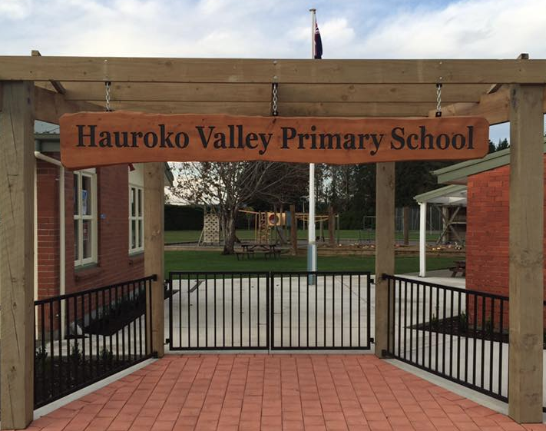

Please return the next section back to school.

Permission Requests

Dear Parents/Caregivers

Throughout your child’s time at Hauroko Valley Primary, teachers will need to take their classes outside the school grounds on short outings to give the children learning experiences outside the classroom e.g. Science or Social Studies visits, cultural events, sports trips, swimming, etc.
To fit in with Board of Trustees procedures, we need your permission for your child to take part in these activities while he/she is at Hauroko Valley Primary. (Note that any trip involving an overnight stay will require your further permission for that specific event.)
Once signed, the form below will be held at the office.

Day Trip/Transport Permission Form
I give permission for my child to be involved in all day trips and visits during her/his time at Hauroko Valley Primary.
I verify that should I transport children on a school trip my vehicle and the driver will meet the following conditions:
- The vehicle has a current registration
- The vehicle has a current Warrant of Fitness (WoF)
- The safety belt will be provided and worn by each passenger
- I understand that it is the driver’s responsibility to ensure all passengers are wearing their safety belts correctly.
- I hold a current, full New Zealand driver licence of international driver licence or permit.
- I understand that the member of staff in charge of the trip may be required to sight my driver licence and vehicle WoF.

Permission to Release Telephone/Cell phone Details
Your phone numbers are needed to be available to other school families for the purposes of an emergency school closure phone tree and various Home & School and BOT requirements eg fundraising and meeting information.

I give permission for my phone numbers to be available to other school families for the above purposes.

Permission to include child’s photo in school newsletters / school website.

I give permission for my child/ren’s photo to be included in school newsletters /school website from time to time.

Parent/Guardian Name: _________________Child/ren’s Name: ________________________

Signature: _________________________Date: ____________________________________

Hauroko Valley Primary School – Complaints Guidelines (Parents copy)

Caregiver has a concern about something happening at school.

Matter resolved to both parties satisfaction – either concluded and an understanding in place for future action.
Caregiver asks for an appointment with the child’s teacher. Issue discussed with Teacher.

After an agreed period of time e.g. two weeks unsuccessful action (i.e. problem has resurfaced).

Matter unresolved. Complaint put in writing and addressed to the Chairperson of the BOT. The Chairperson then follows the board process for handling complaints.
After an agreed period of time e.g. two weeks action unsuccessful (i.e. problem has resurfaced).
Matter resolved to both parties satisfaction – either concluded and an understanding in place for future action.
Matter unresolved or has resurfaced.
Make an appointment and discuss with the Principal.

- While minor issues may be able to be discussed in a quick informal chat with a staff member, normally in order for both parties to give the matter full attention, arranging a time to discuss the matter is the preferred option.
- If the complaint guidelines have not been followed the Board will normally return any letter of complaint to the writer and ask that they follow the guidelines first.
- The Board needs to formally receive a complaint in order to act on it. If a complaint is serious enough for the board to deal with, it is serious enough to be put in writing. If you have concerns about expressing the matter clearly in writing please discuss the matter in confidence with the Board Chairperson (or another delegated board member) to enable them to assist you with this.
- All parties to a complaint may bring a support person to any meeting where this issue is to be discussed.

